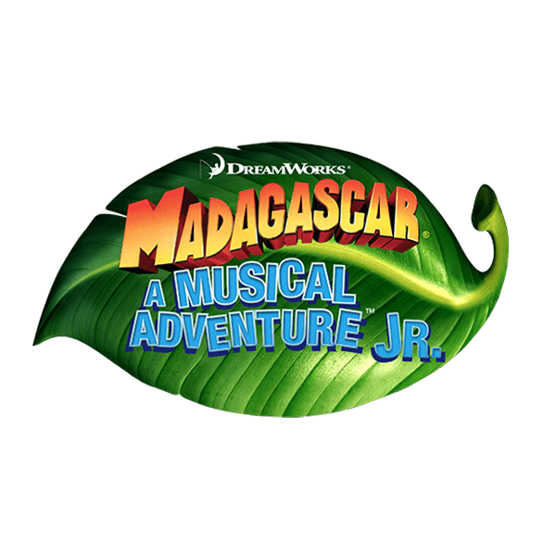

**HERITAGE ELEMENTARY PERFORMING ARTS PROGRAM**

April 4-6, 2025

Heritage Elementary MPR

Dear Advertiser:

Thank you for supporting the Heritage Elementary School Performing Arts Program this year. We have 150+ students hard at work to put on a great show. Our production could not be possible without the support of donors/advertisers like you.

Contact Name: _______________________________________________________________________________

Company Name: ______________________________________________________________________________

Company Address: ____________________________________________________________________________

City: _____________________________________ State: _____________ Zip Code: ___________________

Email Address: _____________________________ Phone Number: _________________________

**Please check one:**

Full Page…………………………………………………………………..………………………$120

Half Page……………………………………………………………….…………………………..$80

Business Card…………………………………………………………………….……………….$50

**Method of Payment:**

Check enclosed1 (payable to “Heritage Elementary PTA”)

Paid by Credit Card at Heritage PTA webstore [www.heritageaviators.com](http://www.heritageaviators.com)

Please submit your payment and artwork by **March 7, 2025**

*We can accept printed camera ready artwork1 or digital artwork2 in JPEG or PDF formats.

1. For Check Payments and/or Printed Camera Ready Artwork, please deliver with this completed form to: Heritage Elementary School: 15400 Lansdowne Road, Tustin, CA 92782
2. For Digital Artwork please email to [**HeritagePerformingArtsAds@gmail.com**](mailto:HeritagePerformingArtsAds@gmail.com)